Order Of Service

Singing: Psalm 91—CW page 100

Reading: Psalm 89:1-4

Opening Hymn: CW 11

Reading: Acts 15:22-29

Request Hymn: CW Supplement 702

Reading: Matthew 5:1-12

Sermon Hymn: CW 19

Sermon Text: Mark 2:13-17

By The Sea Side Again

Prayer

The Apostles’ Creed, TLH page 12

Holy Communion

The Lord's Prayer

The Blessing

Closing Hymn: CW 1

* * * * * * * * * * *

Koinonia Hour

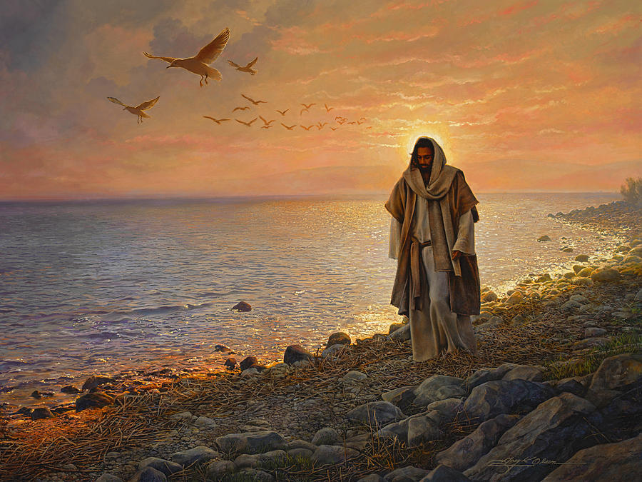

Down By The Sea Again

Water
Of
Life
2 December 2018

W A T E R O F L I F E

Independent Christian Church—Conservative Lutheran Doctrine

Worship Service: 9:30 a.m. Bible Study: 10:45 a.m.

Larry Cooper, Pastor E-Mail address:
111 N. Ridge Road lcooper@wateroflife.cc
Coon Valley, WI 54623 Web Site:
www.wateroflife.cc

* * * * * * * * * * * * * * * * * * * * * * * * * * *

Sermon Text: Mark 2:13-17

By The Sea Side Again

* * * * * * * * * * * * * * * * * * * * * * * * * * *

Mark 2:13 And he went forth again by the sea side; and all the multitude resorted unto him, and he taught them.
:14 And as he passed by, he saw Levi the son of Alphaeus sitting at the receipt of custom, and said unto him, Follow me. And he arose and followed him.
:15 And it came to pass, that, as Jesus sat at meat in his house, many publicans and sinners sat also together with Jesus and his disciples: for there were many, and they followed him.
:16 And when the scribes and Pharisees saw him eat with publicans and sinners, they said unto his disciples, How is it that he eateth and drinketh with publicans and sinners?
:17 When Jesus heard it, he saith unto them, They that are whole have no need of the physician, but they that are sick: I came not to call the righteous, but sinners to repentance.

